**Project Design Phase-II**

**Technology Architecture**

|  |  |
| --- | --- |
| Date | 18 November 2022 |
| Team ID | PNT2022TMID07381 |
| Project Name | Project - **Personal Assistance For Seniors Who Are Self-Reliant** |
| Maximum Marks | 4 Marks |

**Technical Architecture:**

**Table-1 : Components & Technologies:** 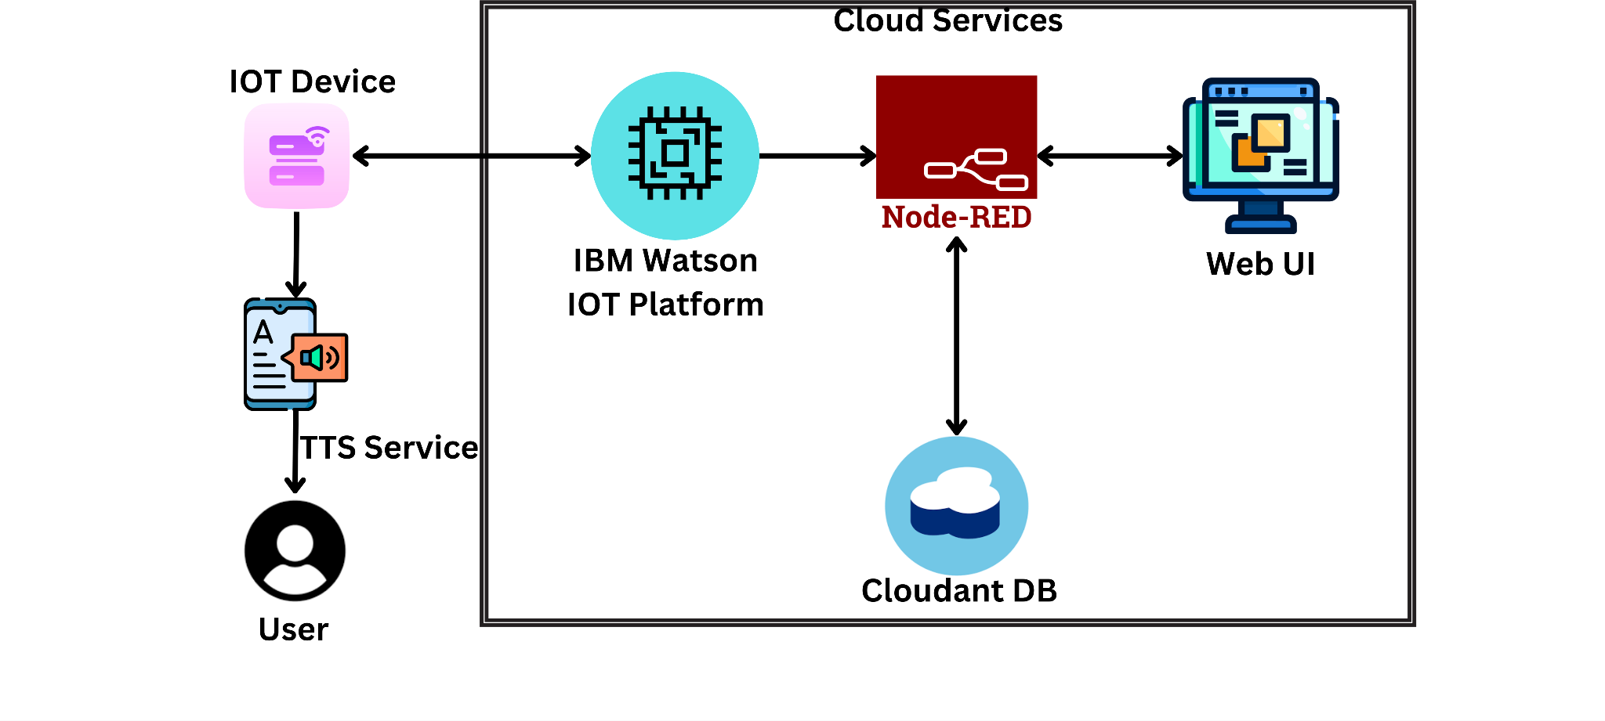

|  |  |  |  |
| --- | --- | --- | --- |
| **S.No** | **Component** | **Description** | **Technology** |
| 1. | User Interface | User interacts with the mobile application UI. | HTML, CSS, JavaScript / Angular Js / React Js/C/C++ |
| 2. | Application Logic-1 | Updates medicine schedule,doctor’s appointments and suggest diet plan . | Java / Python |
| 3. | Application Logic-2 | Create a speech notification with the medicine details at the scheduled time. | IBM Watson TTS service |
| 4. | Application Logic-3 | Interactions with the IOT device. | IBM Watson IoT Platform. |
| 5. | Database | Medication schedule and doctor’s appointments. | MySQL, NoSQL |
| 6. | Cloud Database | Database Service on Cloud. | IBM Cloudant |
| 7. | File Storage | File storage requirements - App code and IoT credentials are stored | IBM Block Storage or Other Storage Service or Local Filesystem |
| 8. | External API-1 | To get the data from the IBM cloud | REST API |
| 9. | External API-2 | To get the login credentials in IBM DB2 | Login API |
| 10. | Infrastructure (Server / Cloud) | Host the server and application | Cloud Foundry, Node-Red. |

**Table-2: Application Characteristics:**

|  |  |  |  |
| --- | --- | --- | --- |
| **S.No** | **Characteristics** | **Description** | **Technology** |
| 1. | Open-Source Frameworks | To develop the application interface, we use MIT App Inventor | MIT App Inventor |

|  |  |  |  |
| --- | --- | --- | --- |
| 2. | Security Implementations | To secure the users login credentials and personal information. | e.g. SHA-256, OWASP |
| 3. | Scalable Architecture | To enhance the scalability o application database | IBM auto scaling |
| 4. | Availability | To make use the application and data available to the registered users | IBM Cloud load balancer |
| 5. | Performance | To increase the performance , the application is hosted in the high performance instance. | IBM instance |